Laboratory work №5
python
Student name: Nuraly Nurislam
Student ID: 25B030223
Data:25.11.25

1 task
Code should convert temperature to Celsius or fahreheit
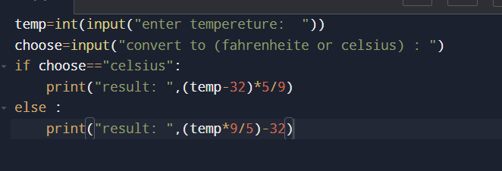
Here I write code with if else because I think its effective and here result:
